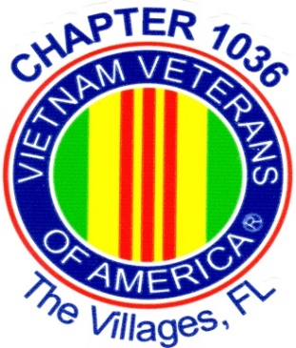

Parady Financial Group
Presents
Vietnam Veterans Chapter 1036
8th Annual Charity Golf Tournament
Monday May 18, 2020
Cane Garden Country Club
The Villages, FL

Wave Start - 1:30 PM Shotgun

Dinner following golf - 6:00PM
at Lake Miona Recreation Center

Registration $95 per Player

Team Captain: Golf Id #

Phone: Email:

Player 2: Golf Id #

Player 3: Golf Id #

Player 4: Golf Id #

Will you need a rental cart? Yes No

Cancellation and Payment Information:
- If golf scramble is cancelled due to weather or other events, all prizes will be distributed during a drawing at the banquet at Lake Miona Rec Center. After May 1st. entry fee is non-refundable.

- Make Checks Payable to “Cane Garden” return this completed form and check to the Cane Garden Pro-Shop.

- For additional information please contact Sonny Baker at sonny.baker@vva1036.org , phone contact (413) 233-7110.

Please visit our web-site at www.vva1036.org

