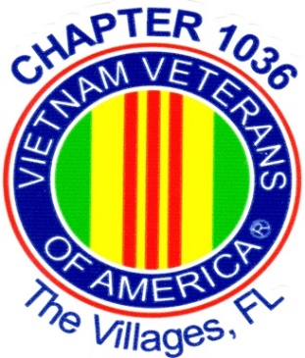
Vietnam Veterans of America
Chapter 1036
11th Annual Charity Golf Tournament
Monday October 2, 2023
Bonifay Country Club
The Villages, FL

Check-in Starts at 10:00 AM
Lunch at 11:00 Noon at Bonifay Restaurant
Wave Start - 12:45 PM Shotgun
Registration $100 per Player

Team Captain: Golf Id #

Phone: Email:

Player 2: Golf Id #

Player 3: Golf Id #

Player 4: Golf Id #

Will you need a rental cart? Yes No

Cancellation and Payment Information:
- If golf scramble is cancelled due to weather or other events, all prizes will be distributed at a drawing at our General Membership Meeting on
November 7, 2023 at Lake Miona Rec Center. After September 30th entry fee is non-refundable.

- Make Checks Payable to “Bonifay Country Club” - Return this completed form and check to the Bonifay Country Club Pro-Shop.(1033 Pinellas Pl, The Villages, FL 32163) Registration Starts on August 1, 2023

- For additional information please contact Bob Alt at bob.alt@vva1036.org , phone contact (608) 354-2474.

Please visit our web-site at www.vva1036.org

