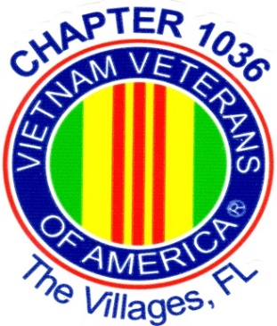
Vietnam Veterans
of America

Chapter 1036 – The Villages

Pancake
Breakfast

Saturday May 6, 2023
7:30 to 11:00 A.M.
@
Bonifay Country Club
1033 Pinellas Pl, The Villages, FL

$8.00 Donation
Proceeds Fund the Vietnam Veterans of America Chapter 1036 The Villages Charitable Activities for Veterans Issues and Area School Programs

